**Promote versus certify**

**Introduction**

Power BI’s endorsement feature is important for identifying reliable data that can be shared within your team to ensure accurate analysis.

In this reading, you’ll explore the basics of promotion and certification and review the process steps for certifying content in Power BI.

**Power BI endorsement**

The Power BI endorsement feature comprises two options: promotion and certification. Each option serves a unique purpose in elevating content visibility and trustworthiness within an organization.

Endorsement in Power BI can be applied to various content types, enhancing their credibility and visibility within the organization.

The content types that can be endorsed include:

* Datasets
* Dataflows
* Reports
* Apps

These endorsements help distinguish reliability and approval levels, facilitating a more organized, trust-centric collaborative environment.

**Promotion versus certification**

As you’ve just learned, you can promote or certify content in Power BI. Let’s take a closer look at the differences between these two options.

**Promotion**

* **Aim**: To highlight valuable content deemed fit for sharing and utilization within the organization.
* **Who can promote**: Content owners or those with write permissions on the respective workspace.
* **Visibility**: Labeling promoted content facilitates easy identification in Power BI and external platforms like Excel.
* **Use Case:** At Adventure Works, Lucas owns the **Sales Report** dataset. He must ensure its content is easily accessible to the sales team. He can use Promotion to highlight the dataset in the workspace, giving quick access to team members.

**Certification**

* **Aim:** To signify content alignment with organizational quality standards, marking it as reliable and authoritative for wide organizational use.
* **Who can certify:**A select group of reviewers, defined by the Power BI administrator, authorized to certify content.
* **Visibility:** Certified content is distinctly labeled and is prioritized in some search results, aiding easy identification.
* **Use case:** Adventure Works relies on authorized financial experts to ensure data reliability in their financial dashboard. Building a data integrity confirmation process, they certify it as **Certified Financial Data**, signifying it meets strict quality standards and is the organization's most reliable source for financial analysis.

**The promotion process**

Before promoting content, ensure you have **Write** permission for the workspace in which the content is located. Follow the steps below to promote a trustworthy report:

1. Navigate to the workspace where your content resides. Select the ellipsis symbol and **Settings** to access the content’s settings.

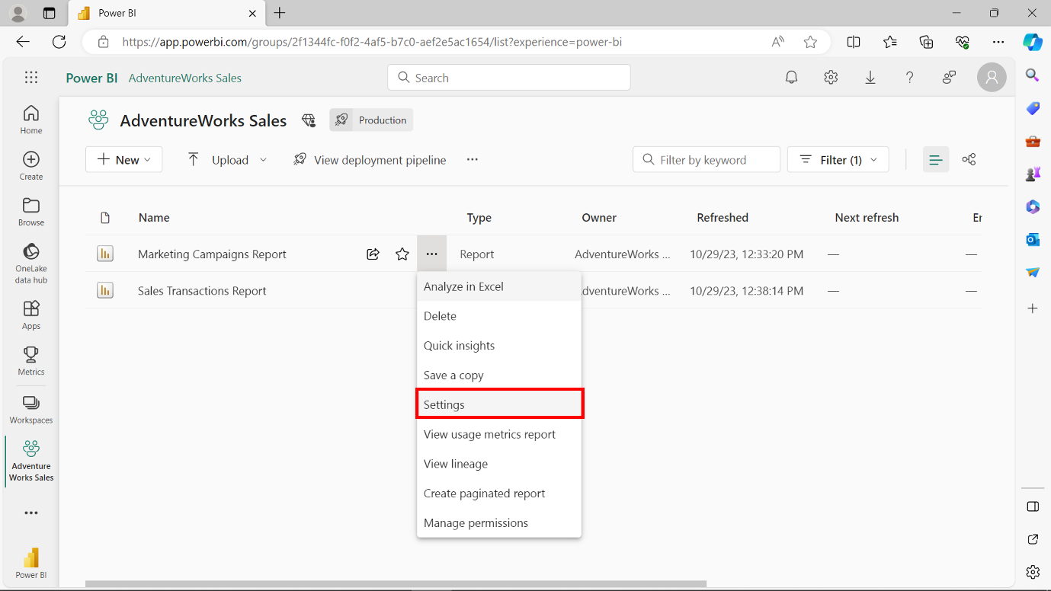

1. On the **Settings** window, navigate to the **Endorsement** section.

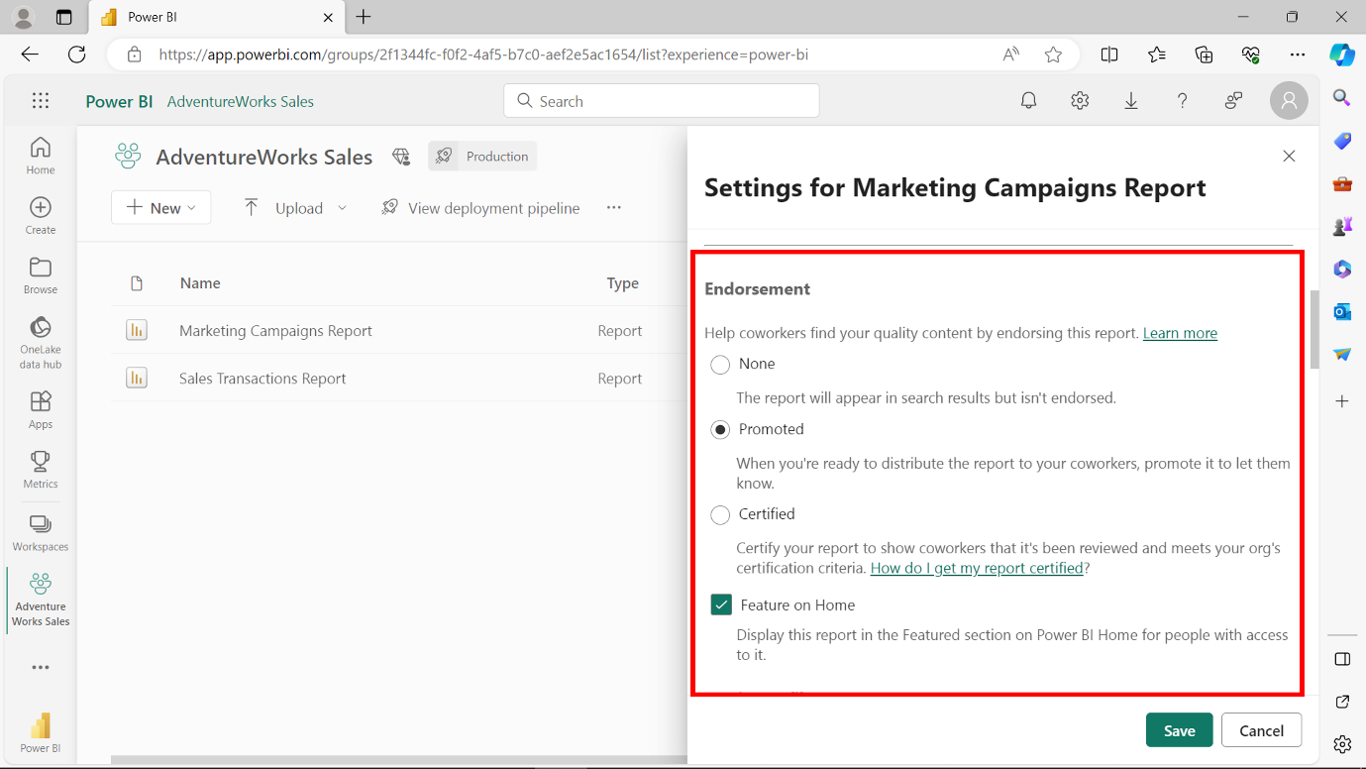

1. Select **Promoted** to promote the content.

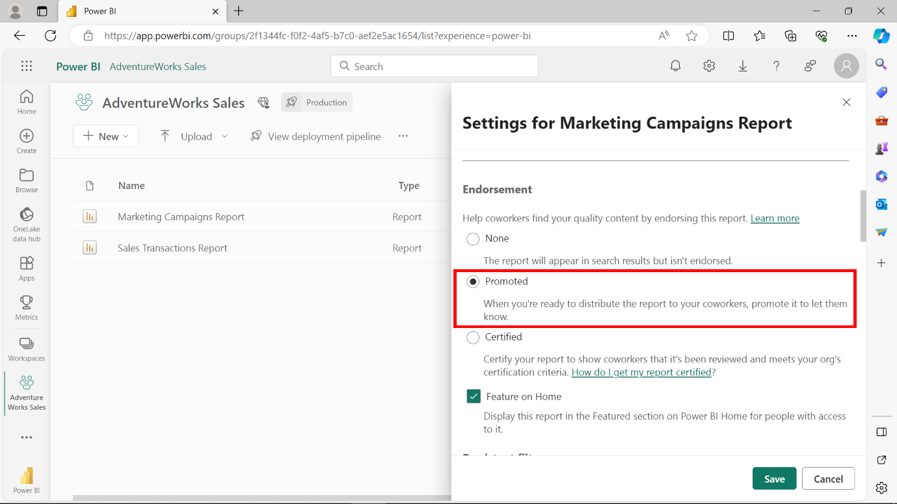

1. You can also enable **Feature on Home** to pin the promoted content to the Power BI Service home screen. This highlights the content for everyone who can access it.

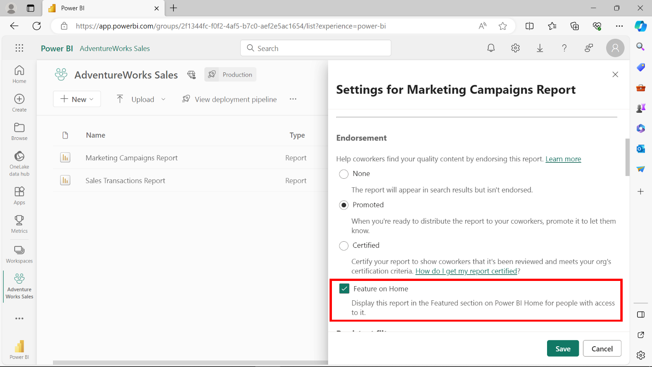

1. Select **Save** to apply your settings.

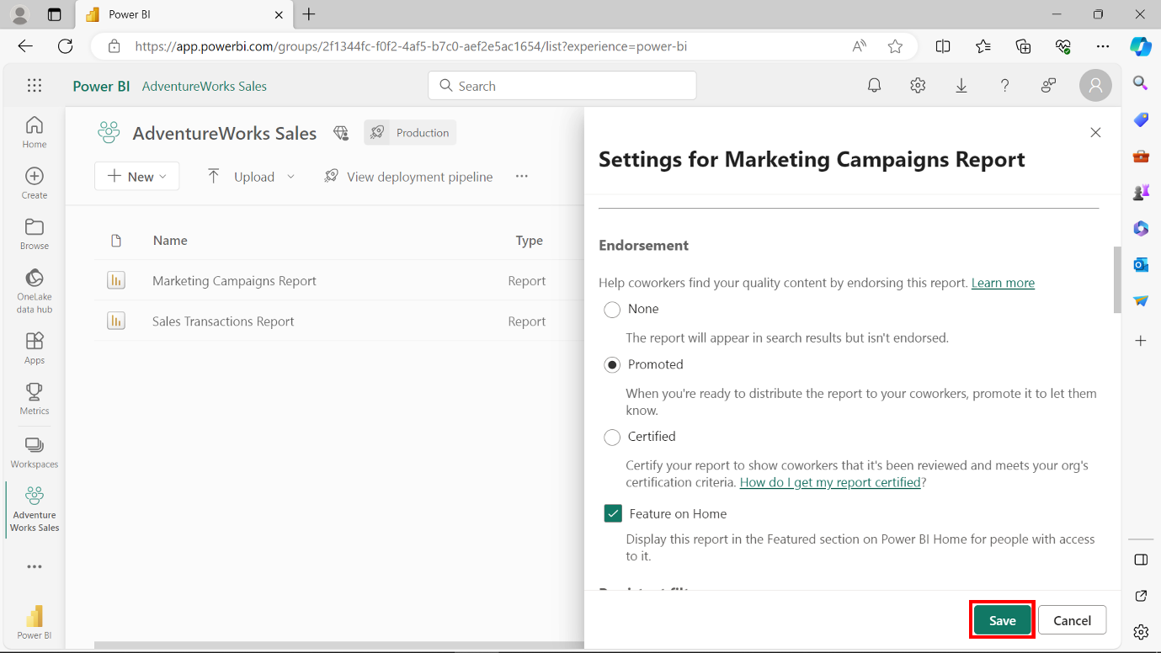

1. The **Promoted** endorsement appears to the right of the endorsed content.

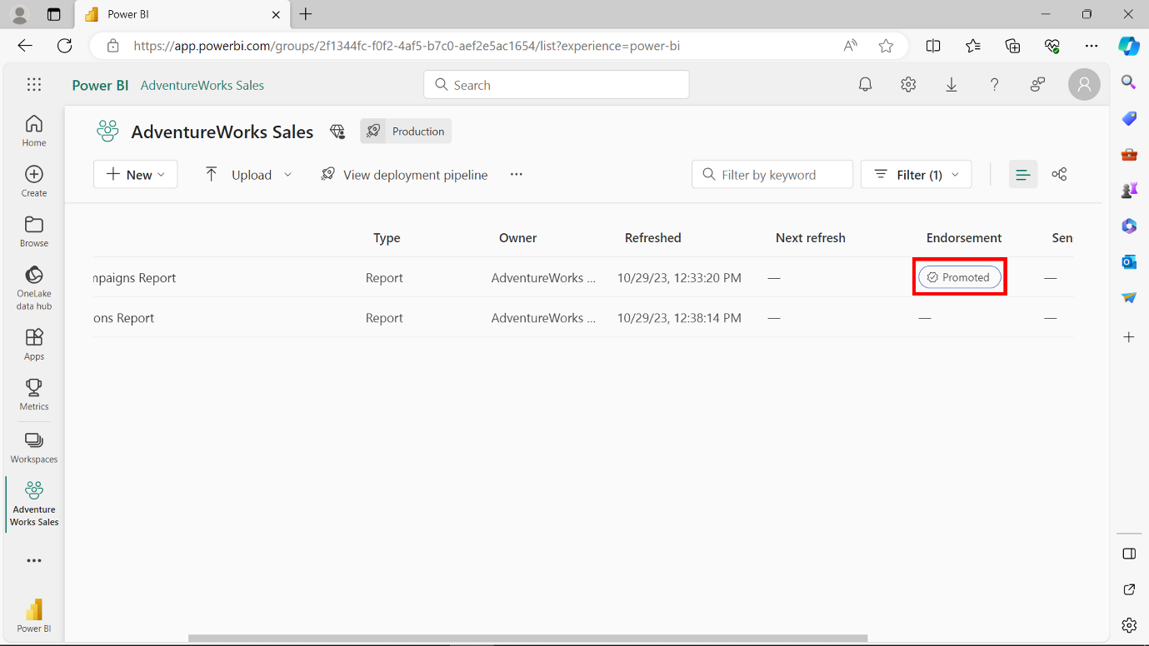

**The certification process**

The administrative setup for certification ensures a structured approach to content certification. This helps to maintain a controlled environment for this crucial endorsement tier. Follow the steps below to enable certification:

1. Select **Settings** to open the **Settings** menu.

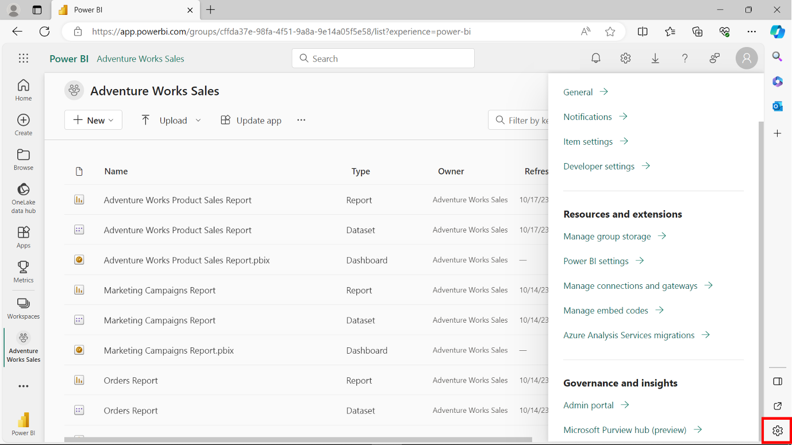

1. From the **Settings** menu, select **Admin** portal.

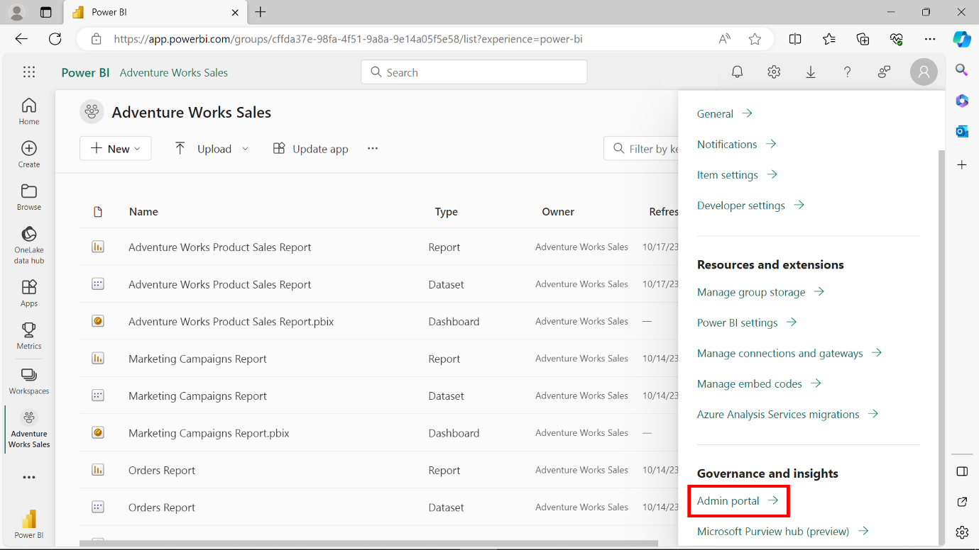

1. In the **Admin** portal, navigate to **Tenant** settings.

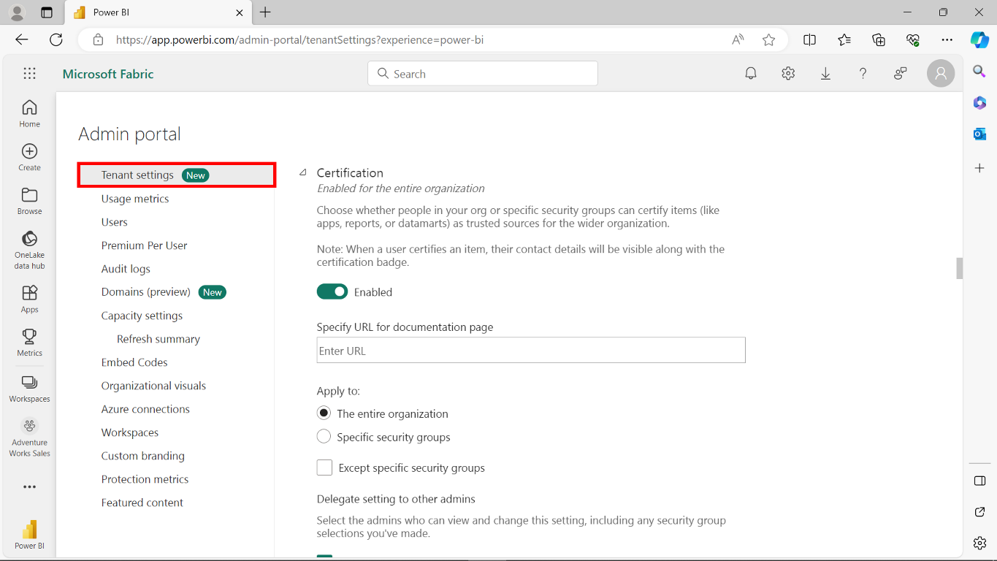

1. Under **Export and sharing** settings, expand the **Certification** section and set the toggle to **Enabled**.

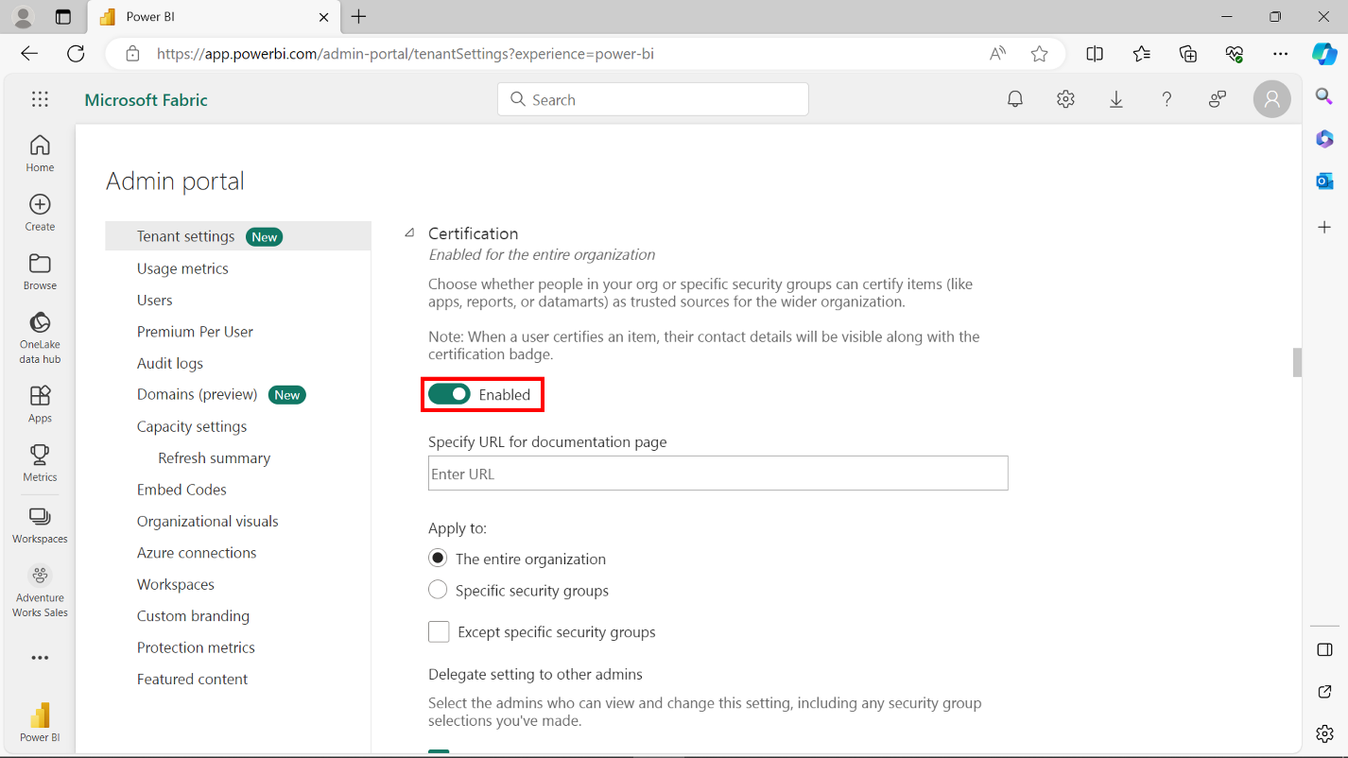

1. Under **Apply to**, specify security groups whose members are authorized to certify content. Members of these groups can access the **Certification** option in the **Endorsement settings** dialog box.

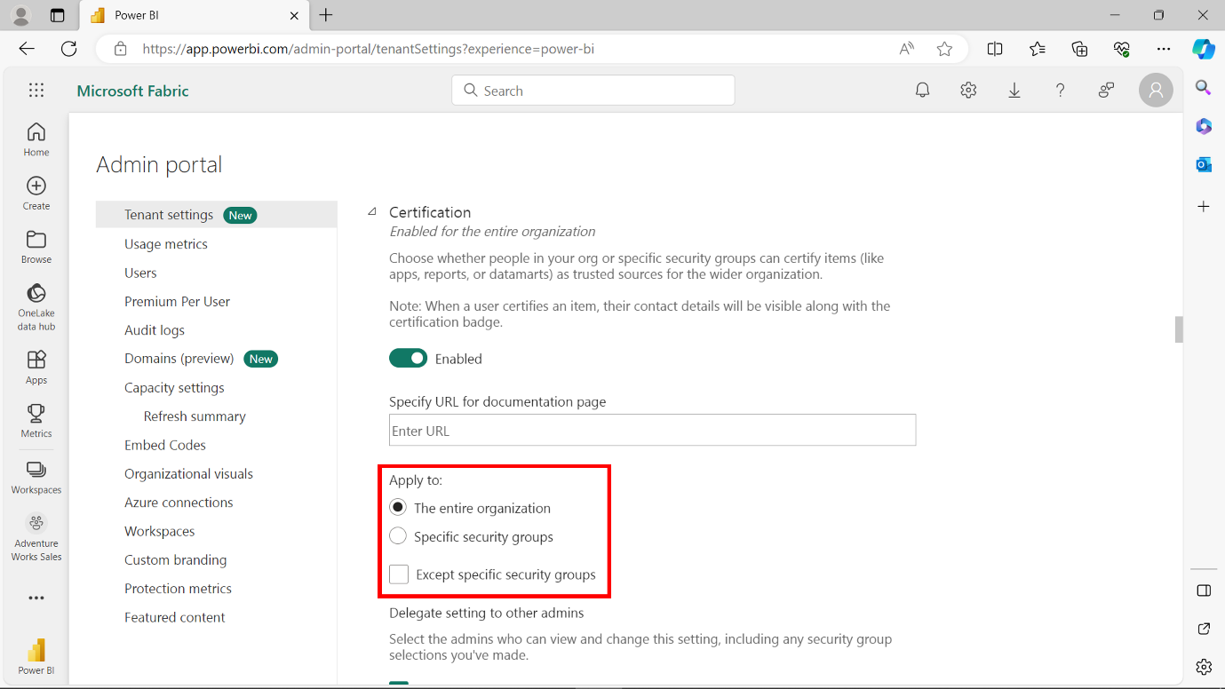

1. If available, provide the organization's published certification policy URL. This URL is a reference point for users seeking to engage in the certification process.

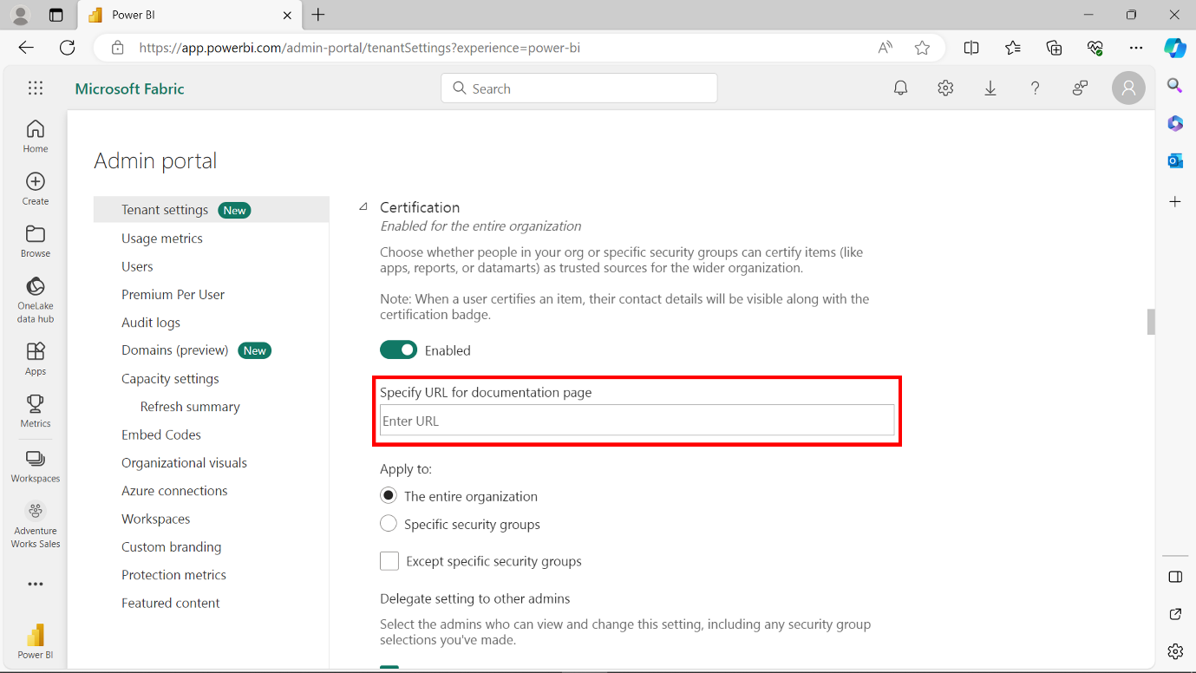

1. By following this process, users can assess content for accountability and accuracy. They can then certify this content, endorsing its high data integrity standard.

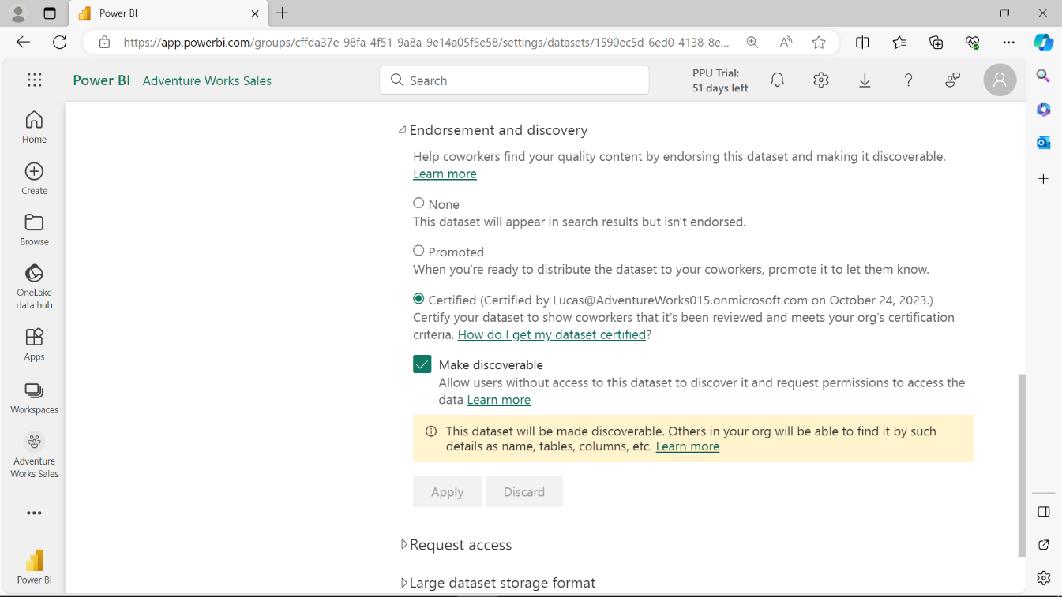

**Conclusion**

With its promotion and certification tiers, the endorsement feature provides a robust mechanism for fostering trust and quality assurance in Power BI. It distinguishes between general recognition (promotion) and authoritative endorsement (certification). This contributes to a productive and reliable collaborative environment in Power BI.